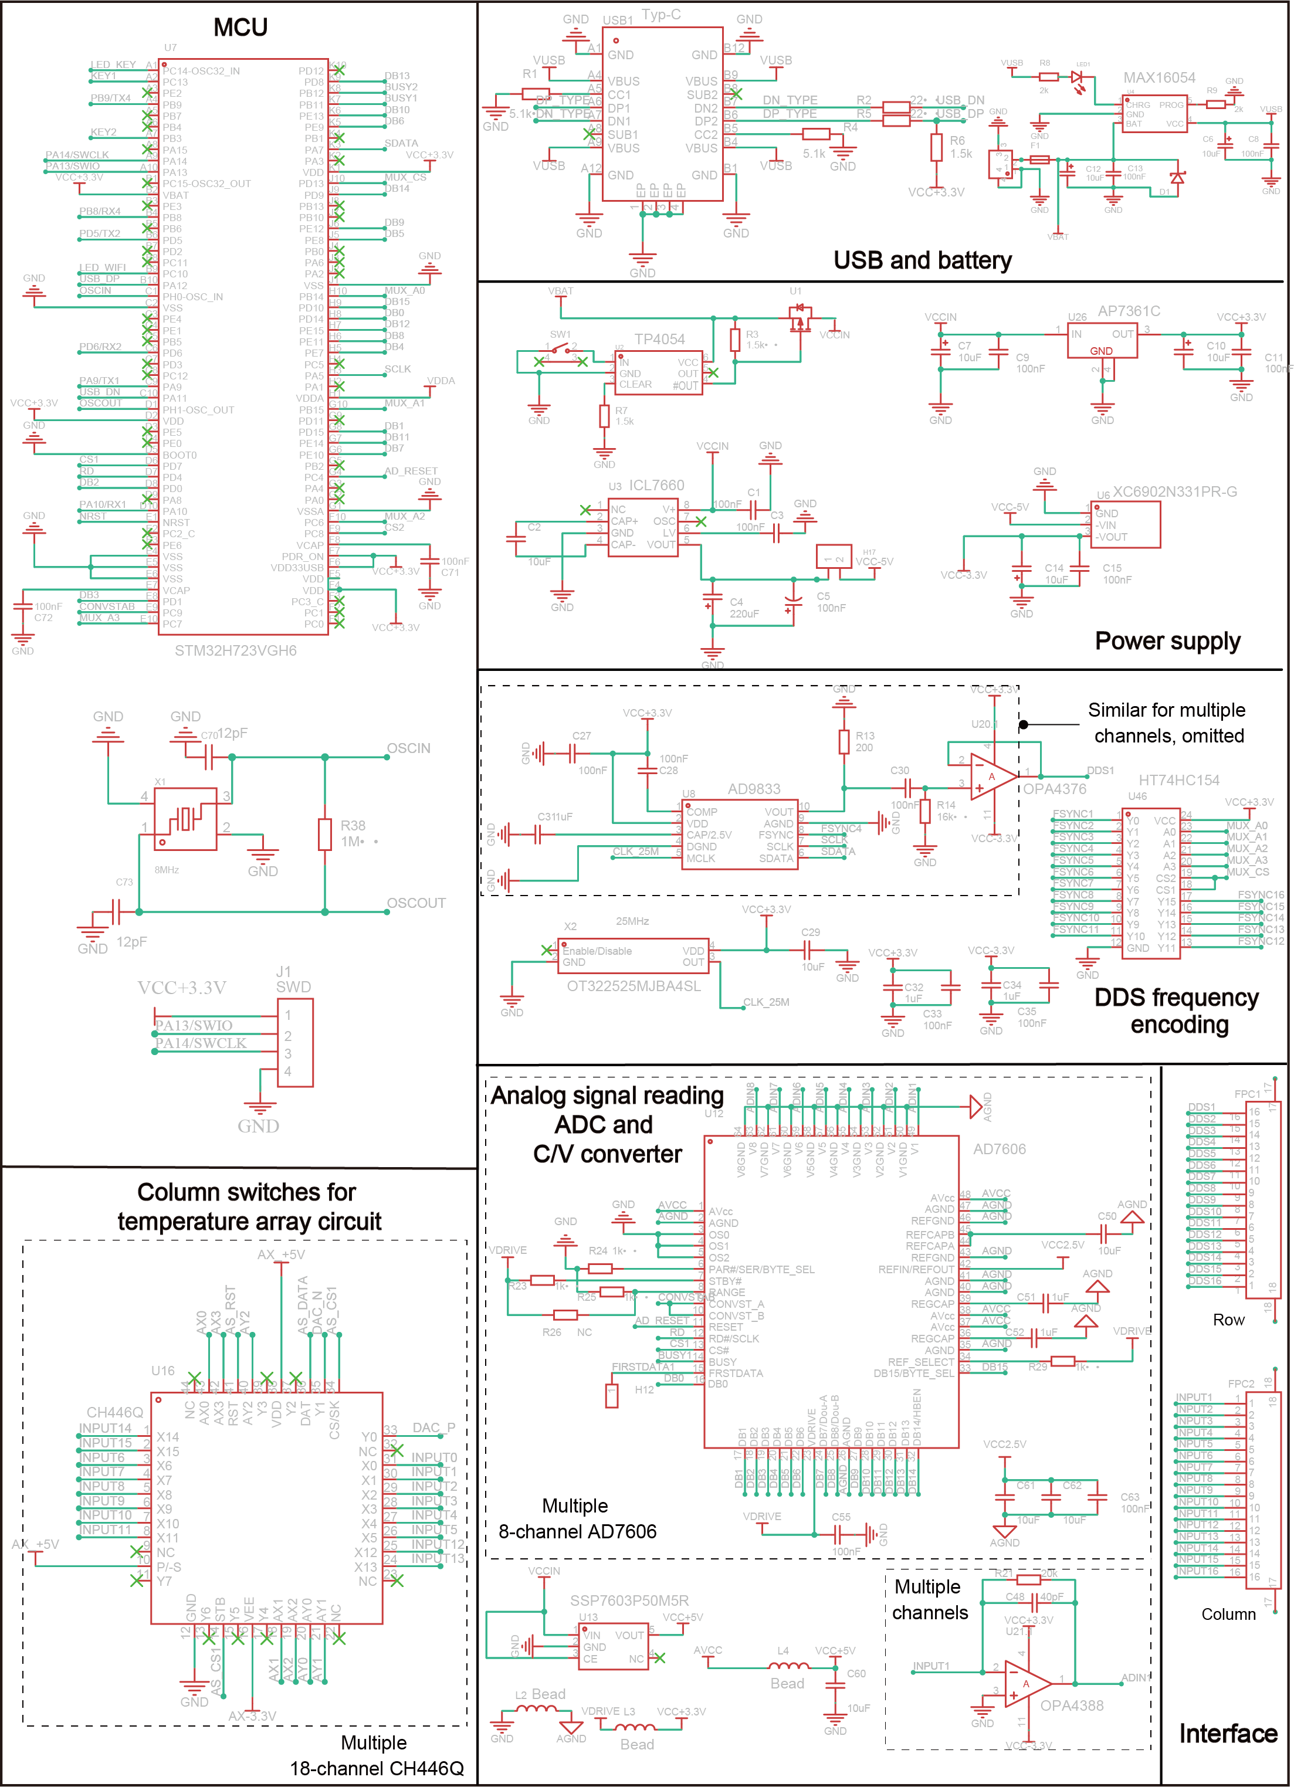

Supplementary Figure 14. Schematic Diagram of Core Components in the Data Acquisition Circuit. This diagram presents an overview of the key modules and components, highlighting the essential functional units of the microcontroller unit (MCU), USB interface, power supply, frequency encoding, analog signal processing and acquisition, analog switch units, and sensor connection interfaces.

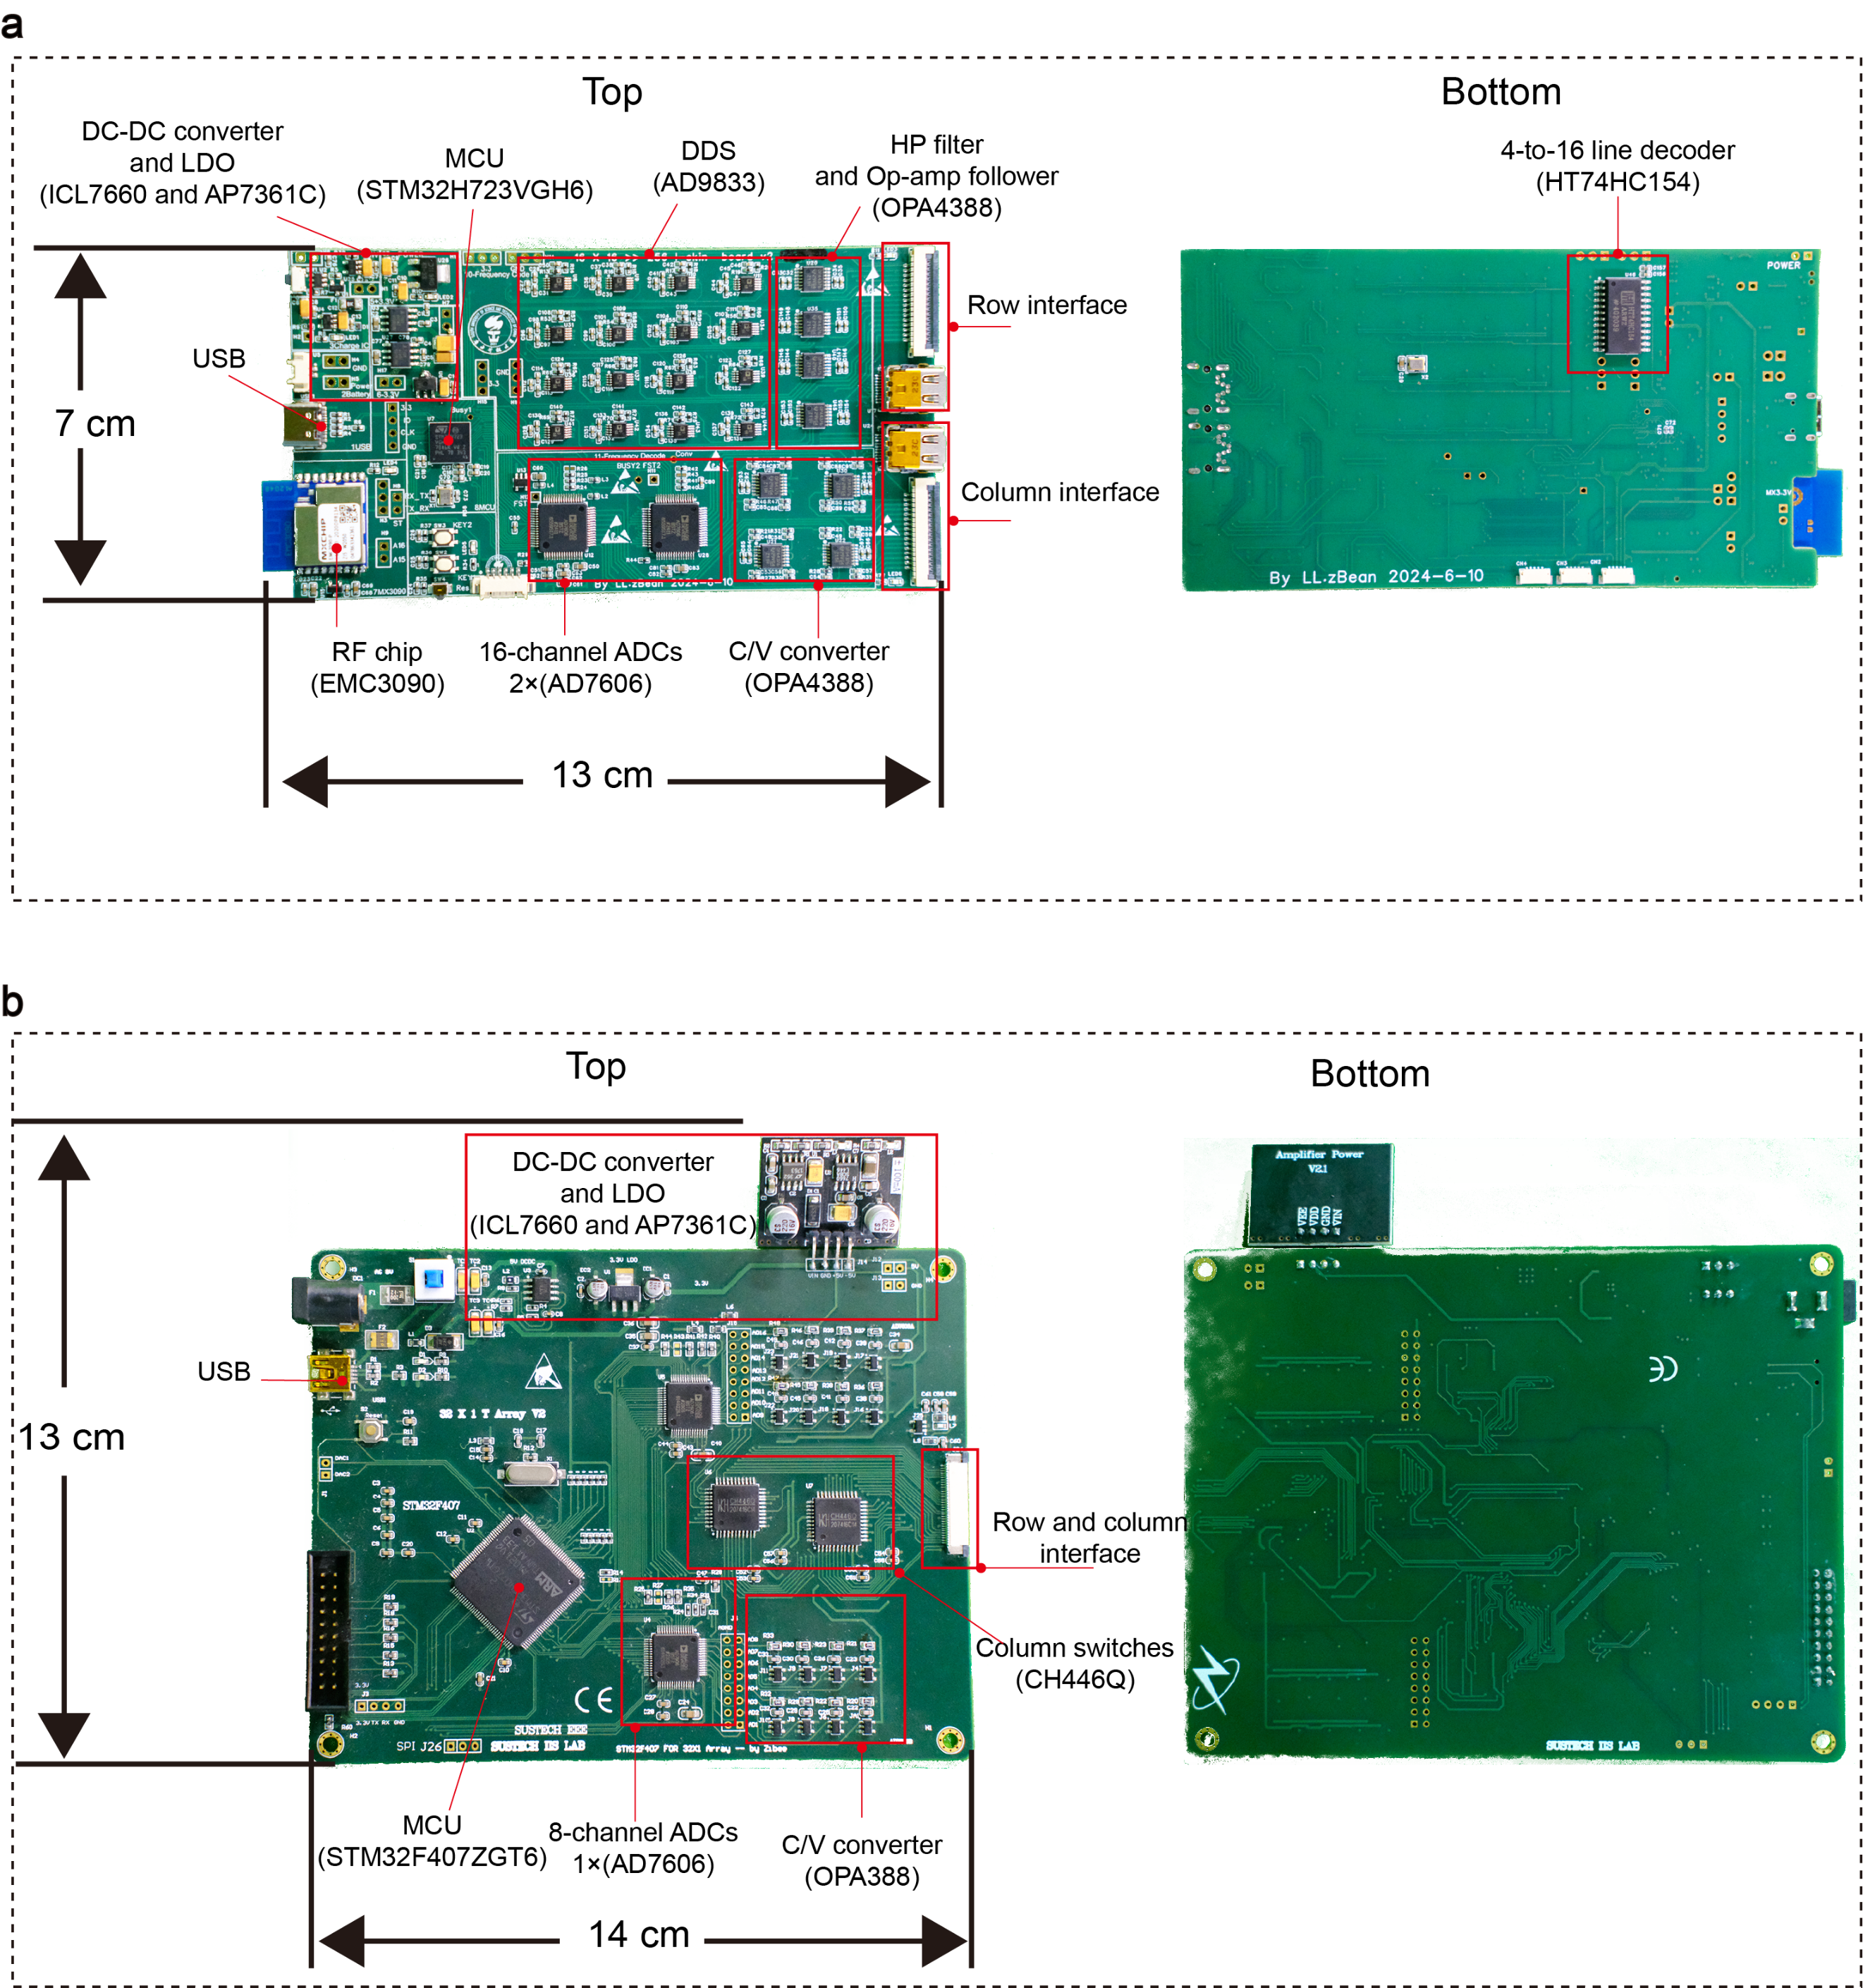
Supplementary Figure 15. Physical PCB layout of the data acquisition board. (a) Printed circuit board (PCB) layout for the pressure skin array acquisition circuit. (b) PCB layout for the temperature skin array acquisition circuit. All chip models and component types are labeled in the diagram.

Note: For more design details and principles, see the main text and supplementary materials.

